FRIENDS OF BISHOP’S HOUSE, IONA

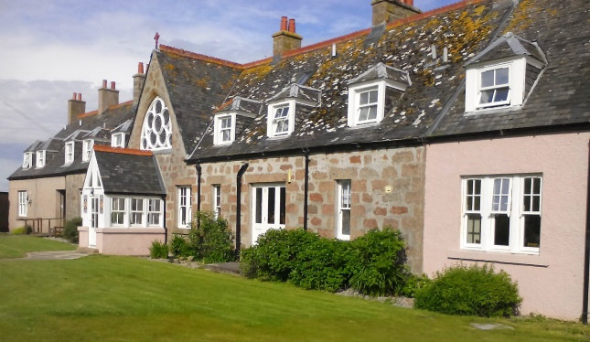

Bishop’s House

IONA

Argyll

PA76 6SJ

01681 700111

iona@island-retreats.org

# NEWSLETTER – SUMMER 2023

Unlike many years at Friends’ Week we experienced the best weather the islands have to offer in June when the sun never stopped shining, so we were all very healthy and refreshed by the end of the week, having made the most of the glorious weather, whether walking, swimming, climbing or, in lots of cases, just enjoying sitting in Bishop’s House garden. One highlight for some of us was a boat trip to Staffa in absolutely perfect conditions. While some went ashore and walked to Fingal’s Cave, others climbed to the top of the island to see the numerous puffins which nest there, and a few of us remained on the boat and sailed round the island to view all the wonderful rock formations.

One of the main topics of conversation during the week was the fact that the roof needs to be replaced. It had been hoped that the work would have been done earlier this year but unfortunately there was a delay and now it is hoped the work will be started in the early part of next year. We are all very conscious of the cost involved in such a major undertaking, as a result of which we made a number of suggestions at the AGM about how we might help to cover some of the costs by fundraising by the Friends.

These included -

* buying a roof tile for £5.00
* asking all the Friends of Bishop’s House to make a donation direct to the Treasurer
* making a donation via the Just Giving page online (<https://www.justgiving.com/fo-bishopshouseiona> mentioning the roof in the comments

It was also decided to prepare a leaflet and add details on Facebook and our Website to bring notice of the fundraising effort to as many people as possible. Obviously if any of the Friends have other ideas about fundraising, please let the Secretary know.

In the meantime, if you are able, please send any contributions to the Honorary Treasurer: *Mr Toben Lewis, Beannachd, Isle of Iona, PA76 6SP*. Please make cheques payable to Friends of Bishop’s House, Iona, or online payments labelled “Roof” to Bank of Scotland, Western Isles Branch, Account No 00211892, Sort Code 80-09-73.

Finally, a reminder from the Treasurer, that some subscriptions for this year are still outstanding. If in doubt about your subscription, please contact Toben at the address above or to toben@tobenlewis.com

Again, if you receive this Newsletter by post and now have an e-mail address, please let me have the details, or indeed if there are changes to your postal address.

*Mrs Helaine Ross, The Elms, Crieff Road, Aberfeldy, Perthshire PH15 2BJ*