** FRIENDS OF BISHOP’S HOUSE, IONA **

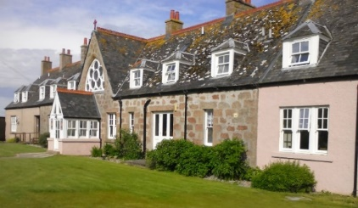

The Bishop’s House

IONA

Argyll

PA76 6SJ

01681 700111

iona@island-retreats.org

**NEWSLETTER – Christmas 2020 **

Dear Friends,

It has been a very difficult year for all of us and there has been so many things happening in what has seemed a very short year for some and very long year for others. The Bishops House has not been open since just two weeks after the end of work week in March and the staff have been furloughed so please remember Robbie our house manager and Karina who has returned to Romania and Declan who has returned to Ireland.

There has been some sad news just recently with news of the sudden death of Anne Robinson, of the Revd Dr Henry Sefton and the news of the death of Crawford Morrison, the Post Master on Iona. All the visitors to the Island noticed the black cat in the post van – Postman Crawford and his black and white cat. They will all be greatly missed.

I have also heard from Robbie today that Mrs Hazel Harrison, a long time member of the Friends of Bishops House, is very unwell and has moved into a care home.

There has also been some good news to celebrate and many of you who manage to get to Friends Week will remember Idris and Zara Crumlish and we are very pleased to hear that Revd Liz Crumlish was Ordained on the 13th of December.

Please remember all these our Friends in your prayers

**Now we wait** – not for the end of the virus or Brexit but something more important. Something that brings glad tidings of great joy for the coming of Christ into our lives again and for ever.

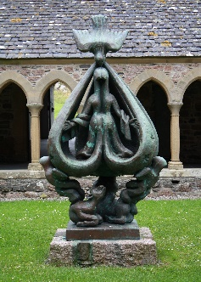 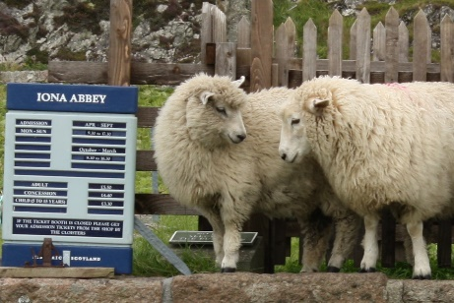 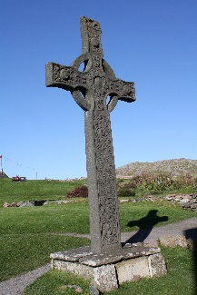

Do not be afraid We’re all right it doesn’t say anything God is with us.

about sheep, we can follow the shepherds.

May God bless you all and keep you safe 

**Nicola**

Revd Nicola Reynolds Hon Sec. Contact tel 01697 508465 email [nicola.reynolds2@talktalk.net](mailto:nicola.reynolds2@talktalk.net)