**FRIENDS OF BISHOP’S HOUSE, IONA**

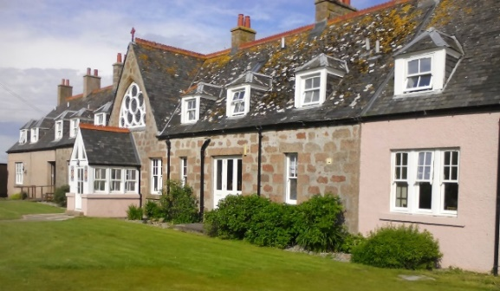

The Bishop’s House

IONA

Argyll

PA76 6SJ

01681 700111

iona@island-retreats.org

**NEWSLETTER – Summer 2020**

Dear Friends,

As you may be aware this year the AGM could not take place at The Bishop’s House because of the Corona Virus, however we used an online package that allowed some of us to gather together electronically and see each other. This was our first attempt at using the internet to link up for the AGM and sadly there were problems. Thanks to the Zoom package Robbie was able to walk us around the House to show us the new lights in the dining room and the new coasters in the lounge but not the new electric scooter as the weather was wet and windy. He also gave us a view of what we were missing. The Minutes of the AGM will give you more information about what has been happening whilst the House has been locked down and we have set the dates for the Friends Week, the AGM and Work Week for the next two years. Those who had booked for Friends Week this year have been offered the opportunity to move their booking to next year.

We have had a request for a link to make donations, especially at this time, to the Friends of the Bishop’s House and Toben our Treasurer been able to set up the **Just Giving** page. The link for donations is here: <https://www.justgiving.com/fo-bishopshouseiona>

This is also displayed as a link on our website (<http://www.friendsofbishopshouse.com/help-the-friends/>).

**The AGM**

This was an interesting event with a Zoom link was set up by Revd Paul Rider and we were very grateful to Paul for hosting this.

Attached you should find Minutes of the AGM, the Treasurers report and the Accounts and Robbie’s Not the Wardens Report. Please let me know if the attachments do not arrive for those receiving by email.

**Work Week** this year was difficult to get to thanks to the weather but we arrived and managed to do virtually all the work needed despite the Secretary managing to destroy a step ladder. The woodwork in the Chapel and around the House was waxed and Declan, who with Karina had stayed on after the lockdown, have continued to keep it polished and rewaxed during the shutdown. Robbie was able to take us up to the balcony using his laptop to show us the Chapel and it was a very moving moment for us all.

One of our members, who has been a stalwart for Work Week reached the age of 90yrs this year and when she attended Synod, which took place in Oban during Work Week, Bishop Kevin asked the Synod to sing Happy Birthday to her twice to remind them all how long they must wash their hands for to stay safe in these difficult times.

Margaret Harrison, who is 91 yrs old, had joined us for the Zoom meeting and was so pleased this was computer link available as she was not able to get to the island any longer and really missed being at the Bishop’s House. With the use of Zoom she said was able to see people she knew again and to be walked around the House. It was suggested that even if we were able to get to the Bishops House in person next year for Friends Week and the AGM we also used a Zoom link so that more people could join us. This was agreed and it will be investigated to be set up through Zoom or another programme for the Bishops House.

**Online Shopping to support the island economies**:

As you may be aware travel restrictions and isolating has been affecting the Iona island community with only local people able to access the ferries. Some of you may have been planning to purchase things from the shops on Iona when you visited this year but there is a website you can visit where you can buy things on line. The websites covers virtually all the islands around Scotland but it easy to use and pick out the Iona shops.

Please consider supporting the Iona community and have a look at what is available by visiting: **isle20.com**

I have heard so much from Friends this year because the virus and it is also good to be able to put faces to names through Zoom but we also remember that there are many Friends who do not have access to the internet and we hold all our Friends in our love.

God bless you all and thank you for being OUR FRIENDS.

May God bless you all and keep you safe

**Nicola**

Revd Nicola Reynolds

Hon Sec.

Contact tel 01697 508465 email [nicola.reynolds2@talktalk.net](mailto:nicola.reynolds2@talktalk.net)