**FRIENDS OF BISHOP’S HOUSE, IONA**

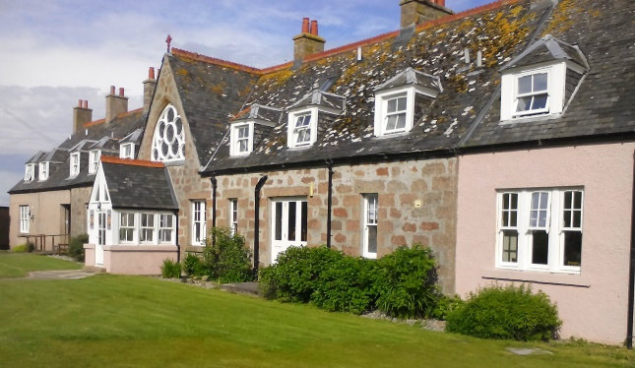

Bishop’s House

IONA

Argyll

PA76 6SJ

01681 700111

iona@island-retreats.org

**NEWSLETTER SUMMER 2018**

Friends’ Week was as eventful as ever and we were all pleased to hear that Robbie McLellan had been appointed Manager of Bishop’s House. Robbie has been at the House for nearly 20 years having carried out many jobs during that time so it seems very fitting that he should now be given this responsibility.

It was good to see the new windows in place, making a massive difference to the entrance to the Chapel. It had been the intention that the Bishop would dedicate the windows after the AGM but unfortunately due to Storm Hector and the fact that all the ferries were off and he was unable to get to Iona, we had a service incorporating a thanksgiving for the windows conducted by Revd Canon Alan Bennett, who was also celebrating 50 years in the priesthood.

During the week the Chapel was out of bounds for about 24 hours while stonemasons came in to point the walls and make the Chapel wind and water tight and there was some anxiety while scaffolding was being taken in and out that the new windows might come to harm but thankfully no such disaster occurred.

We managed to persuade David Kirkpatrick, the skipper of the Iolaire, to take us on a trip anti-clockwise round Iona on a beautiful, sunny evening. Once we got round to the west side of the island, it became very choppy but we had a running commentary from David (to distract us!) about all that could be seen on the horizon including many of the other Hebridean islands.

We were made aware that the inhabitants of Iona are fundraising for a new Village Hall to replace the existing one which is no longer fit for purpose. The nursery children (and their parents) held a fundraising event which a number of us attended and enjoyed lots of home made cakes and sweets.

Unfortunately our own Coffee Morning was on the day of Storm Hector and because the ferries were off, we had to rely mainly on the residents of Iona to support us, along with the few visitors who were staying on the island. However, it was still a very successful event and it was great to see people supporting our own fundraising efforts. We also record our thanks to all the Friends who sent donations of gifts and money for the Coffee Morning.

We were sad to learn of the death of Jeremy Wilson who had been Joint Warden of Bishop’s House with his late wife Hilary in the nineties. At the end of Friends’ Week we also learned that the Revd Dr George Grubb, a long time Friend, had died too. We extend our sincere sympathies to the families of all the Friends who have died in recent months who gave so much support to the work of The Bishops House Iona.

It was mentioned in the Spring Newsletter that Carole Barclay was going to receive Maundy Money from the Queen at St George’s Chapel, Windsor and this is her account of the event.

“On 16 November 2017 I received a letter from the Royal Almonry, Buckingham Palace, inviting me to St George’s Chapel on Maundy Thursday where the Queen would distribute Maundy gifts of specially minted coins to the recipients who had been chosen from dioceses across England and Scotland. The numbers of recipients would be 92 men and 92 women (the 92 equalling the Monarch’s age). My name had been submitted by the Dean of Chapel Royal in Scotland and I was required to complete a short resumé of my Pastoral Link work at St Mary’s Episcopal Cathedral in Edinburgh over the past 30 years. I understand one of the criteria for being selected is that recipients must be over 70 years of age so I qualified!

Maundy Thursday was a cold, blustery day at Windsor, and St George’s Chapel had all the doors open as we sat awaiting the Queen and all the processions. During this time we listened to wonderful music by the sub-organists from St George’s and the Chapel Royal and appreciated the magnificent surroundings. My seat was number 2 on the aisle near the Sanctuary from where I had a very good view of the Queen and noticed that she sang all the hymns after her Equerry opened her handbag and passed her glasses to her.

The service was like Evensong with anthems, prayers and readings, and the General Thanksgiving before the singing of the National Anthem. The singing by the Choir of the Chapel Royal and St George’s Chapel was superb. The Choir sat with the Yeoman and Clergy behind a nave altar. The six Alms dishes used for the distribution were on the nave alter with the Queen sitting on a seat on the right.

The Queen presented each recipient with two purses – one white and one red – and as I received mine I gave a little bow and, as instructed, said “Thank you your Majesty”. As the Queen is the same height as I am, I looked at her straight in the eye and smiled

This year the red purse contains a £5 coin commemorating four generations of Royalty, and a 50p coin commemorating the Representation of the People Act 1918, which reformed the electoral system in Great Britain and Ireland, giving some women the right to vote for the first time. The gifts are symbolic of an allowance for clothing and provisions formerly given in kind. The white purse contains Maundy coins amounting to as many pence as the Sovereign’s age, which in this case is 92.

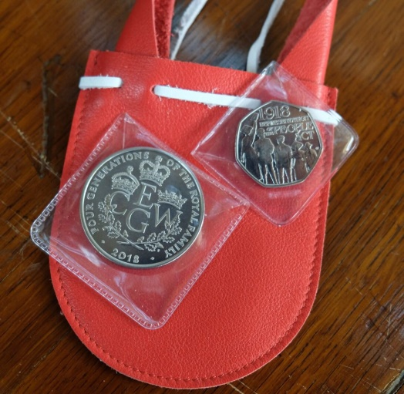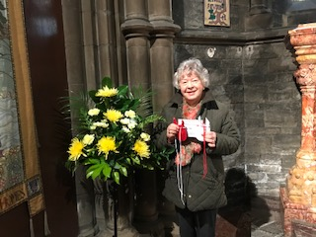

*As it was not permitted to take photos in the Chapel in Windsor this is me in St Mary’s Cathedral with the purses*

After the Blessing, the Queen and the processions left the Chapel, the bells of the Curfew Tower ringing as the Wandsmen escorted us to the State Apartments of Windsor Castle for the reception given by the Queen and hosted by the Constable and Governor of Windsor Castle. The reception was held in St George’s Hall used for state banquets, the Hall where the ceiling, roof and east wall were destroyed by fire in 1992 and which have since been fully restored. We later were able to have a little tour of the some of the other State apartments.

This was a very special occasion which I will never forget and, of course, an honour to receive the Maundy Money from the Queen.

**Carole Mary Barclay –** April 2018.”

Thanks again to Yvonne who has produced another interesting Newsletter for us to enjoy.

Final word from the Secretary:- a reminder from Clephane Hume, the Treasurer, that some subscriptions for this year are still outstanding. If in doubt about your payment, please contact Clephane (her address is at the top of the Minutes) and she will be happy to receive monies!

Again, if you receive this newsletter by post and now have an e-mail address, please let me have the details, or indeed if there are changes to your postal address.

The Revd Nicola Reynolds, 6 Browns Houses, Prospect, Wigton, Cumbria, CA7 2LB [nicola.reynolds2@talktalk.net](mailto:nicola.reynolds2@talktalk.net)