**FRIENDS OF BISHOP’S HOUSE, IONA**

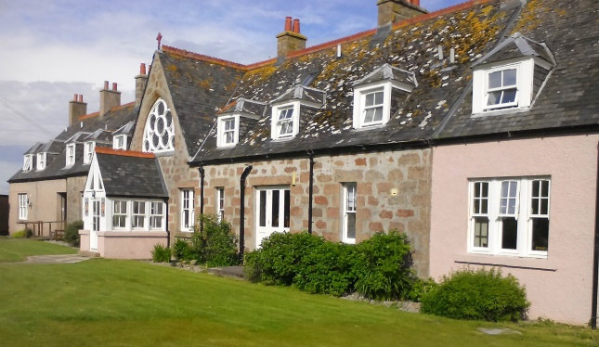

Bishop’s House

IONA

Argyll

PA76 6SJ

01681 700111

iona@island-retreats.org

**NEWSLETTER – SPRING 2019**

Once again there was a very successful Work Week earlier in the year and as usual lots of work was done both in the House and the garden to prepare them for the guests.

Here we have a group of the Friends who took part. By the looks of some of the ladies’ trousers, there must have been a fair amount of paint involved!!!

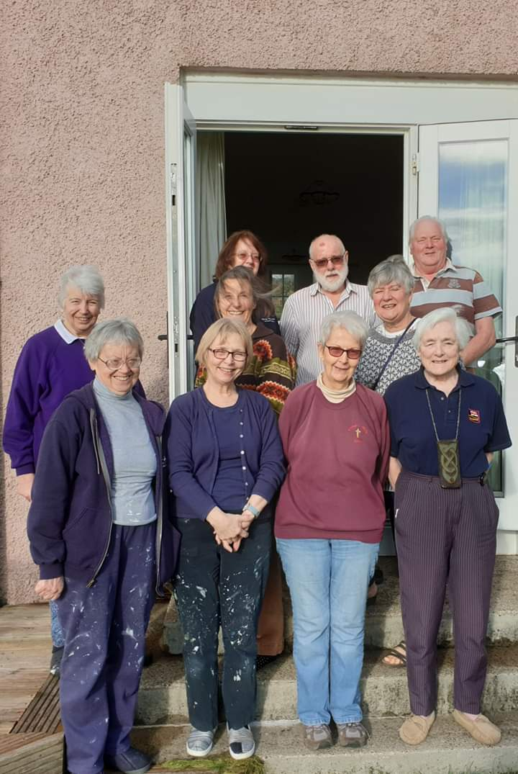

Last summer following the installation of the new windows at the entrance to the Chapel, we were unable to have them blessed by the Bishop as he was unable to reach the island due to stormy weather, so, better late than never, Bishop Kevin is going to bless the windows at a special service on Thursday, 20 June at 4.00 pm and we are delighted that Anita Pate the glass artist is hoping to be present.

I enclose an Agenda for the AGM. If you are unable to attend on 20 June, let me have comments or anything to add to the Wish List or anything you wish to have raised under AOB, by **6 June**. **For those attending the AGM, remember to bring your copy of the Minutes, sent with the Summer 2018 Newsletter.**

Friends will again hold a major fund-raising event for Bishop’s House on the Island, a Coffee Morning and Sale, on Thursday, 20 June. If you would like to make a donation, or have gifts of jewellery, bric-a-brac, books or handicrafts, please either bring them to Friends’ Week or send them to me **at Bishop’s House**, but not before Saturday, 15 June.

**Parking at Fionnphort**

A while ago we received information that the Council are considering making the free Carpark at Fionnphort fee paying and will possibly set the fee at £7.00 a day. Whilst this will affect those of us that drive the key issue is the impact this will have on the economy of the Mull and Iona community. The Friends Of Bishops House Committee responded in writing to the Council but it appears this fee may be introduced and an online petition has been set up by the Iona Island Community Council and we have been asked to respond. Please consider making a response to this petition in support of the Iona Island Community Council. A copy of the message we received is below:

*Argyll & Bute Council are set to introduce these charges having ignored the ground swell of objections and the carefully laid out response from Iona island Community Council.*

*Petition - #stopislandparkingtax*

*Here’s a link to the Petition re parking charges at lifeline ferry ports - see also Twitter with above hashtag. It only went live late afternoon yesterday and has 750+ signatures already. Please circulate it to anyone with an interest in Iona or other Scottish islands - the Petitions team is aiming for the Scottish Parliament Petitions Committee to consider it at its last pre-recess session on 27 June:*

*Here’s the link to the petition webpage:*

[*http://www.parliament.scot/GettingInvolved/Petitions/freeparkingatlifelineferryports*](http://www.parliament.scot/GettingInvolved/Petitions/freeparkingatlifelineferryports)*.*

*The Area Committee, which comprises 8 Argyll and Bute Councillors, is meeting on 12 June and we understand that is when they’ll consider this terrible proposal. We’re also doing a lot of work to make them more informed, but sheer numbers on the Petition could be really helpful for focusing their minds.*

**Newsletter**

This is the Friends Newsletter and it would be really good to have articles from Friends about their experiences of Iona, poems, thoughts etc for future editions.

A reminder from the Treasurer, that some subscriptions for this year are still outstanding. If in doubt about your payment, please contact the Honorary Treasurer: Revd Clephane Hume, 26 Findhorn Place, Edinburgh EH9 2JP, [cah@clephane.plus.com](mailto:cah@clephane.plus.com)

Funally, I have still not received GDPR forms from 45 Friends and after the AGM will only be able to keep the names on the database if anyone is still in doubt whether they have returned a GDPR form or wants to know what this is all about please get in touch because I am sure you still want to keep up to date with what is happening.

Every blessing

**Nicola**

The Revd Nicola Reynolds, 6 Browns Houses, Prospect, Wigton, Cumbria, CA7 2LB [nicola.reynolds2@talktalk.net](mailto:nicola.reynolds2@talktalk.net)

MEETING OF THE FRIENDS OF BISHOP’S HOUSE, IONA

**on**

**20th June 2019**

# A G E N D A

# Welcome and opening devotions

1. Apologies for absence
2. Minutes of the AGM held on 14th June 2018
3. Matters arising
4. Report on Island Retreats Ltd
5. Treasurer’s report, and Statement of Accounts
6. Secretary’s report
   1. Friends Website
   2. Update on GDPR
7. Election of Secretary
8. Election of Treasurer
9. Election of Friends’ Society representatives
10. Warden’s Report and Wish List
    1. Discussion re Parking issues
11. Date of Friends’ Week 2020 and of next AGM,
12. Date for Work Week
13. AOB