FRIENDS OF BISHOP’S HOUSE, IONA

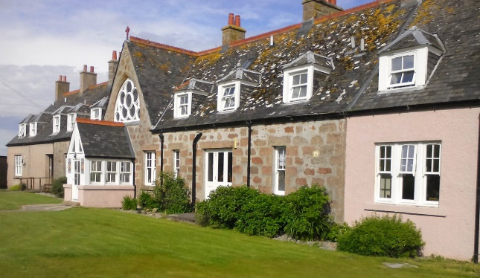

Bishop’s House

IONA

Argyll

PA76 6SJ

01681 700111

iona@island-retreats.org

# NEWSLETTER – SUMMER 2017

Perhaps this Newsletter should be renamed MONSOON 2017 as we seem to have had our fair share of very heavy rain in Scotland this year and for the first time in a long time, it rained every day at Friends’ Week in June – not all day but every day. However, as usual it didn’t dampen the spirits of the Friends who joined for another enjoyable stay at Bishop’s House with an opportunity to meet the new Warden, Marianne and her staff, who do a wonderful job in making the House such a welcoming place to visit.

Following the recent sad deaths of Joan and Dorothy we held an emotional commemorative service instead of Compline one evening, when we also took the opportunity to remember all of the Friends who have died in recent years and whose contributions to the House have been immeasurable. Since then we have also heard of the death of Nick Horton who acted as Chaplain several times and we take this opportunity to send our condolences to his widow, Judith and their family.

A Friend, who wishes to remain anonymous, has sent a generous donation to Bishop’s House and suggested a flower fund should be set up in memory of Joan, who always sent flowers to decorate the Chapel at Easter particularly, so that this lovely tradition can be carried on. Rather than this money being sent to the Treasurer, the suggestion is that it is kept in a petty cash box in the office and should be used for special occasions. If you would like to donate to such a fund, please send your contribution direct to the Warden, making cheques payable to Friends of Bishop’s House please.

In July it was announced from Glasgow University that timbers excavated from Tor an Aba outside Iona Abbey in 1957 have been carbon dated to the time of St Columba. So at last here is proof of the long held belief that Tor an Aba “The Hill of the Abbot” was indeed his cell – his place of study and prayer.

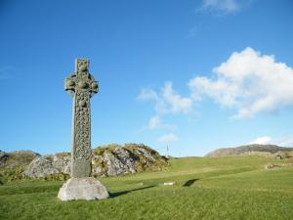 St Martin’s Cross with Tor an Aba

At the time Revd Joyce Watson who is a Friend as well as being the Episcopalian priest on Iona, but was reported as being “The priest in charge of St Columba” - not St Columba’s Chapel! - wrote -

***“Without a doubt, for visitors and residents alike, for people of faith, and people whose interest is primarily to do with history, this brings us closer to those long ago days of the first Christians in our islands. In imagination we may see Columba, working away by the light of an oil lamp on a dark winter night with the wind swirling around outside. We can sit on top of the rocky hillock and sense a presence. Well, some people do; there are those who come here and are keenly aware of a spiritual presence especially around the Abbey, others less so. Whether this news is received primarily with the heart or with the head, it is good news.***

***Proof is exciting, but when it comes to the things of the spirit it’s not so often given. God is too big, way beyond human reasoning, and to have concrete proof of, for example, the Resurrection of Jesus Christ, would reduce God to our level and take away the mystery which is part of faith.”***

As reported in the Spring 2017 Newsletter the Friends are currently responding to the idea that has been put forward to complete the installation of windows in the Chapel by replacing the opaque windows at the entrance of the Chapel with similar etched ones, which will give light at the rear of the Chapel and make it feel more open and welcoming.

The designs are now complete and the people at the AGM were enthusiastic about them but we still need to raise a sizeable sum - in the region of £12,000 - to accomplish the installation. Thanks are due to all those who have made donations so far and anyone who has been quietly fundraising should let the Treasurer know. All donations made will be matched from existing funds.

Please send any contributions to the Honorary Treasurer: Revd Clephane Hume, 26 Findhorn Place, Edinburgh EH9 2JP. Please make cheques payable to Friends of Bishop’s House Iona or BACS transfers labelled “Windows” to Bank of Scotland, Western Isles Branch, Account No 00211892, Sort Code 80-09-73.

Marianne has written –

“We’re now entering the final furlong of our main season, with only eight weeks left…  Thirty-six groups down and nine to go. (And yes, we’re probably all quite relieved that ‘To everything there is a season…’!)

Snippets of news are that Stella Holmes had to leave the team early (but hopes to be back next spring), and so we welcome Lizzie Danes as a new General Assistant to help us over the finish line.  (Lizzie has stayed at Bishop’s House a couple of times – as has her mother!)  We were blessed to host the brothers of the Society of St John the Evangelist (often affectionately known as the Cowley Fathers), who were custodians of Bishop’s House for 12 years, and who visited as part of a special retreat, celebrating their 150th anniversary last year.  To reaffirm the bond between Bishop’s House and the SSJE, and experience the depth of their prayer for this place and Iona, was a privilege.  But there’s always something new round the corner, too. For example, last week, our Danish group were blessed by the candle-lit compline in St Oran’s Chapel that we laid on (beautifully decorated by our Danish volunteer, Hanne, with heather and autumn grasses).

Looking ahead to 2019 (as I type), you’ll probably not be too surprised to learn that only four days in to us opening bookings for 2019, the diary is already looking very full. But fear not, there is still a good amount of space on our 2018 February work week, our Friends’ Week and our Open Weeks.  (Dates are given below.)

Work Week: 22/02 – 01/03/18

Easter Retreat: 28/03 – 03/04/18

Friends Week: 09 – 16/06/18

Open Week #1: 16 – 23/06/18

Open Week #2: 21 – 28/07/18

So if you’d like to make a reservation, do get in touch!  And we look forward to catching up with you at the next opportunity.”

Many of you will know Revd Canon Alan Bennett and Revd Liz Toy both of whom are regular visitors to Bishop’s House. They are both currently receiving medical care so we should hold them in our prayers and wish them good health.

Finally, a reminder from Clephane Hume, the Treasurer, that some subscriptions for this year are still outstanding. If in doubt about your payment, please contact Clephane (her address is at the top of the Minutes) and she will be happy to receive monies!

Again, if you receive this newsletter by post and now have an e-mail address, please let me have the details, or indeed if there are changes to your postal address.

The Revd Nicola Reynolds, 6 Browns Houses, Prospect, Wigton, Cumbria, CA7 2LB [nicola.reynolds2@talktalk.net](mailto:nicola.reynolds2@talktalk.net)