FRIENDS OF BISHOP’S HOUSE, IONA

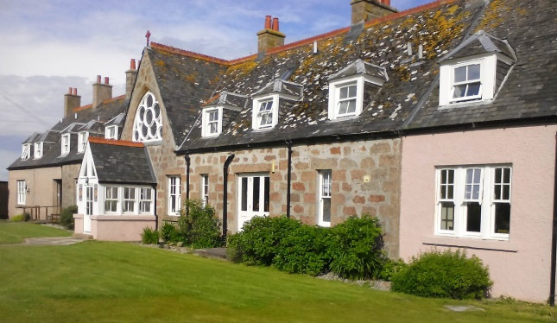

Bishop’s House

IONA

Argyll

PA76 6SJ

01681 700111

iona@island-retreats.org

# NEWSLETTER – SUMMER 2016

Another Friends’ Week has come and gone and once again was a lovely occasion tinged with the sadness of losing Toben as Warden. However, as he and Sarah are continuing to live on Iona we can expect to see them on future visits. Below is a letter from Toben and Sarah which speaks for itself.

We are pleased to be able to announce that a new Warden has been appointed to start in November. She is Marianne Rustad, a Norwegian who also has British nationality. She is currently House Manager at Abbotsford, formerly the residence of Sir Walter Scott. In the interim we are grateful that Sharon Kyle has been “holding the fort”.

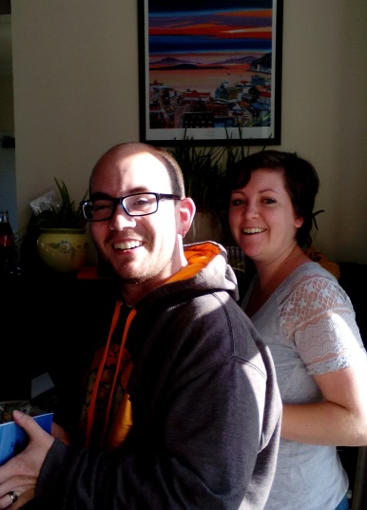Dear Friends, you have once again surprised us. Neither Sarah nor I expected a leaving gift, let alone such a generous one, from all of you. And we thank you from the bottom of our hearts. The depth of kindness you have shown us throughout our time at Bishop’s House, even including our departure, has been phenomenal, appreciated, and sustaining.

We have taken a hint from the many people asking us if we are taking a break, post Bishop’s House, and have booked ourselves a wee holiday on North Uist. Sarah spent many childhood summers at her family’s croft there and we have been meaning to go for quite some time now. Your gift is allowing us to do that. We’ll think of you all when we’re knee deep in a bog and surrounded by midges this August.

Leaving Bishop’s House was made easier by spending a delightful Friends’ Week surrounded by good people as we bid a fond farewell. I look forward to settling into my new role as a Friend who is not the Warden and hope to still see many of you as you visit Iona.

One of our overseas Friends, Revd Paul Rider, has written a note for the Newsletter and this is it – unabridged!

**[With apologies to Mark Twain] A Minnesota Yankee in Queen Elizabeth's Court or**

**How I found a home on Iona!**

“My first experience of Bishop’s House was in the spring of 2009. I was on holiday with a friend and we were staying a few nights at the Columba Hotel. This was the first visit to Iona for each of us [she was a Presbyterian who had never heard of St Columba or Iona]. I happened upon the House for worship one morning and was ignored once the service was over. As I was leaving, someone took me aside and apologized: the group was on a silent retreat and weren’t speaking to anyone - I thought it had something to do with my accent and the way I sang the hymns!

Fast forward two years and I found myself at Open Week at the House. Here is where I met Peter and Anne and Lesley and was totally taken in by their hospitality and grace and fun! It was as if this Yank had been adopted - if only for a few days - and made one of the family. And here is where I learned the difference between a napkin and a serviette, and to say “I am well” rather than I am good” when queried on the state of my general health! My relationship with Bishop’s House has deepened each year since that week.

I was privileged to serve as chaplain for an Open Week for the first time in 2013. Upon my arrival Toben greeted me with words that have stuck with me ever since: “Welcome home!” Home, indeed! I have now been a Friend of Bishop’s House for about four years and have had the thrill and joy of being present during Friends’ Week these past two summers. What fun! It is a grand testament to the special character of this place that draws a wide variety of folk who all have this in common: they are moved by the holiness of this island and the ongoing witness of hospitality that is the hallmark of Bishop’s House. What a joy, also, for me to be present for coffee morning. [I would add that I enjoy the Annual General Meeting -or whatever you call it - but that might make you all think I am a bit weird.] What a blessing to be able to be a part of this and to give back, in some small way, to the House and the people who make it so special.

I am not very good at counting my blessings. But when I do, Bishop’s House and the friends I have made - and continue to make there - are near the top of the list. The warm welcome, hospitable spirit, and holiness of the place fill my soul with joy. I cannot wait until next year, when I can go “home” again!”

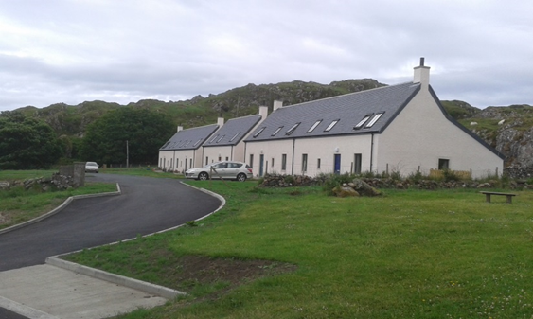

You may recall that in last Summer’s Newsletter was a photograph of the foundations of the new affordable houses being built in the West Glebe Field behind the Church of Scotland on Iona, for island residents. It was a real pleasure to see that the houses are now built and inhabited by five local families including the McLellan’s - Robbie, Jana, Leanne and William.

Once again we held a very successful Coffee Morning where we raised £600 for the use of the House. It is lovely to see familiar faces – both visitors to the island and islanders – in the House, mostly wanting to buy some of the wonderful bread and cakes which have been made by the staff members who must have been up all night baking!

Many Friends continue to do fund-raising for the House and due to their generosity it has been possible to purchase a Smart Car which will enable those visitors to the House who are unable to walk distances to be driven to parts of the Island which would otherwise be inaccessible to them. If you have any ideas for fundraising please share them by letting the Secretary know.

Finally, a reminder from Clephane Hume, the Treasurer, that some subscriptions for this year are still outstanding. If in doubt about your payment, please contact Clephane (her address is at the top of the Minutes) and she will be happy to receive monies!

Again, if you receive this newsletter by post and now have an e-mail address, please let me have the details, or indeed if there are changes to your postal address.

The Revd Nicola Reynolds, 6 Browns Houses, Prospect, Wigton, Cumbria, CA7 2LB [nicola.reynolds2@talktalk.net](mailto:nicola.reynolds2@talktalk.net)