**FRIENDS OF BISHOP’S HOUSE, IONA**

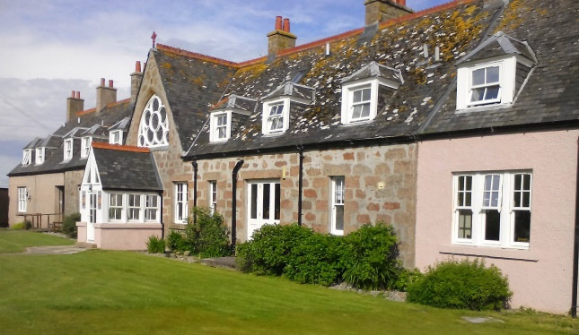

Bishop’s House

IONA

Argyll

PA76 6SJ

01681 700111

iona@island-retreats.org

**NEWSLETTER – SPRING 2018**

At the end of November 2017, we received the following letter from the Warden, Marianne so once again we are looking for a new Warden at Bishop’s House.

*“There's no easy way to say this so let me just jump right in and say that I'm afraid I'll be leaving Bishop's House at some point in the New Year - maybe as soon as the end of January. I gave my resignation to the Board in early November, following news that my mum, Margaret, had been diagnosed with breast cancer.  How the Lord has brought this into the light is incredible - we really feel His mercy and protection, in that respect.*

*My parents' circumstances have been quite finely balanced for a few years now, as some of you may know.  My dad, Michael, is disabled so Margaret is officially his carer; they also live for half the year on our family farm south of Oslo, which we are committed to as a family because we feel the Lord plans to use the place for hospitality in the future.*

*I felt the Lord guiding me that I should honour my parents and support them by leaving this job and bringing forward the move to Norway that I had envisaged doing in a couple of years' time.*

*I would like to thank you so much for your support and encouragement in what's been for me a powerful and rewarding year - stuffed full of blessings and challenges in equal measure (I have to be honest!), but primarily so full of the profound reward of hosting guests in the place we pray becomes their 'home from home' and part of their dynamic relationship with our loving Father, Saviour and Comforter.*

*Do please pray into the appointment of my successor.”*

At the time of writing there is no news about a new Warden, so Robbie and his team are ‘manning the fort’ for the time being. Robbie has said that Work Week went well with all the staff rooms getting a fresh coat of paint and the garden getting its usual tidy up, not forgetting the chapel and library both getting a deep spring clean and sort out. Everyone worked very hard to get things done which was just as well as the workers had to leave a day early due to the beast from the east threatening travel plans. Also, the first group due to stay at Bishop’s House had their arrival delayed as the airports in the south were closed due to the weather.

Following the report that the Friends decided to complete the installation of windows in the Chapel by replacing the opaque windows at the entrance with etched ones, it is pleasing to announce that the windows are now complete and Anita Pate the glass artist hopes to have them installed in the Chapel just after Easter. It therefore seems appropriate that they should be officially dedicated during Friends’ Week so hopefully a special service will be arranged for this purpose.

Although we have received a number of donations towards the cost of the windows, further donations would be appreciated to accomplish the installation, and these will be matched from existing funds.

Please send any contributions to the Honorary Treasurer: Revd Clephane Hume, 26 Findhorn Place, Edinburgh EH9 2JP. Please make cheques payable to Friends of Bishop’s House Iona or BACS transfers labelled “Windows” to Bank of Scotland, Western Isles Branch, Account No 00211892, Sort Code 80-09-73.

I enclose an Agenda for the AGM. If you are unable to attend on 14 June, let me have comments or anything to add to the Wish List or anything you wish to have raised under AOB, by **1 June**. **For those attending the AGM, remember to bring your copy of the Minutes, sent with the Summer 2017 Newsletter.**

Friends will again hold a major fund-raising event for Bishop’s House on the Island, a Coffee Morning and Sale, on Thursday, 14 June. If you would like to make a donation, or have gifts of jewellery, bric-a-brac, books or handicrafts, please either bring them to Friends’ Week or send them to me **at Bishop’s House**, but not before Saturday, 9 June.

**News from the Friends**

It is with joy that we have welcomed Revd Paul Rider on to the Committee. He has moved from the States and been appointed to a parish in Norfolk. It is also exciting to hear that one of the Friends, Carole Barclay, will be receiving Maundy Money from the Queen this year at Windsor, and we hope that Carole will write an article for the Summer Newsletter telling us all about her day.

It would be really good to hear news from Friends to include in the Newsletters so please let me have them. I would also like to suggest that we have a prayer list in the Newsletter but only using people’s first names or just an anonymous prayer request. We can discuss this at the AGM but please let me know your views before Friends’ Week in June.

Finally, a reminder from the Treasurer, that some subscriptions for this year are still outstanding. If in doubt about your payment, please contact Clephane (her address is as above) and she will be happy to receive monies!

**IMPORTANT** Some of you may be aware that there has been a change in Data Storage and Collection regulations in the UK and I must ensure that we conform to these new regulations. Because of these changes I have added a separate form for all members to complete and return to me regarding the data I keep on you. All emails will go out under the bcc setting and I will never pass on contact details to anyone but will pass on the request to you to respond direct. Please complete the form and return it to me whether you are in the UK or elsewhere in the world. If I do not hear from you by the end of May 2018 I will have to delete your contact details but will keep your name on the data base. Again, if you receive this Newsletter by post and now have an e-mail address, please let me have the details as emails are a cheaper way of sending the Newsletter out and, if there are changes to your postal address, please let me know.

The Revd Nicola Reynolds, 6 Browns Houses, Prospect, Wigton, Cumbria, CA7 2LB [nicola.reynolds2@talktalk.net](mailto:nicola.reynolds2@talktalk.net)