FRIENDS OF BISHOP’S HOUSE, IONA

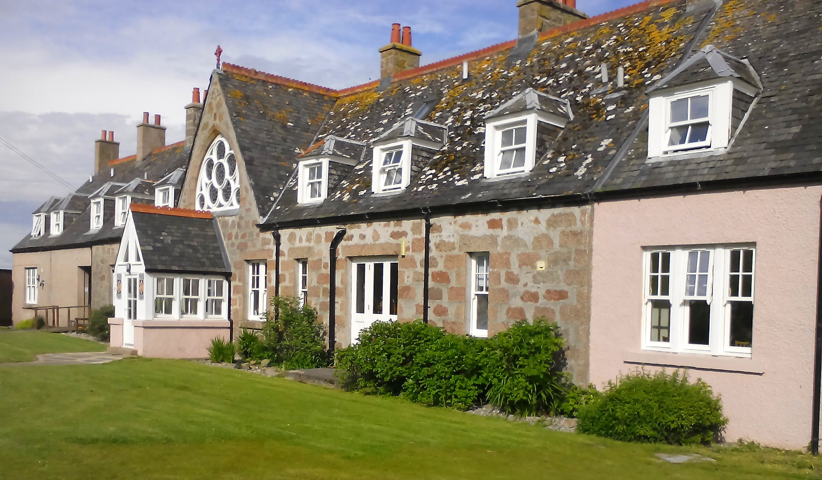
Bishop’s House
IONA
Argyll
PA76 6SJ
01681 700111
iona@island-retreats.org <bhiona@argyll.anglican.org>;

NEWSLETTER – SPRING 2017

Bishop’s House has once again been spruced up during Work Week for the start of another busy season on Iona. Shrove Tuesday occurred during the week and the new Warden Marianne made sure the workers were well supplied with pancakes after a busy day's work.

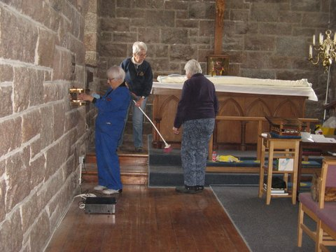
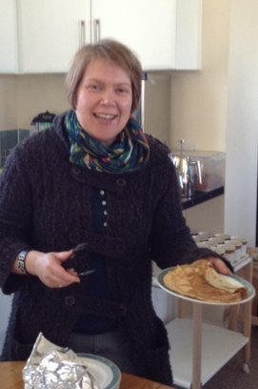

During Work Week we heard the very sad news of the death of Dorothy Jamal, one of the original Friends of Bishop’s House. Dorothy was also Secretary of the Friends for many years and she will be fondly remembered by many not least for her ability to write a poem for every conceivable occasion, many of which have been printed in Newsletters over the years.

While writing this Newsletter we have now heard of the death of Joan Smith another longstanding Friend of Bishop’s House. Joan visited the House many years ago and liked it so much she eventually worked there. She visited the House several times a year at Work Week, Friends’ Week and as often as she could make the journey despite increasing difficulty with her mobility. However, the advent of the mobility scooter at the House gave Joan a new lease of life and she was often seen trundling along the Island’s roads. Joan was never without knitting needles and wool and provided many interesting items for the annual Coffee Morning and Sale.

Both ladies will be sadly missed and we send our sincere condolences to their families and friends.

Marianne has written the following about her introduction to Bishop’s House.

I’ve now been on Iona for four months, and am already feeling very at home in Bishop’s House – like so many before me, I love the atmosphere of this, my new ‘second home’! In recent years I’ve been blessed to work/live in some special environments. Prior to Bishop’s House, I managed the Hope Scott Wing at Abbotsford (the home of Sir Walter Scott), which offers five-star self-catering for groups of 14-16 people. Before that, I lived and worked ‘on community’ at Rydal Hall (the diocesan retreat and conference centre for Cumbria), where I led the kitchen team and was a duty manager. I got into hospitality simply through my enjoyment of cooking and encouragement from church friends – who often ended up at my flat on a Sunday (five doors down from the church). Having grown up in the Borders, these last few years have been something of an unexpected home-coming, but a great opportunity to spend a bit more time with family, most of whom are based in the Borders and Newcastle (when not in Norway, where my father comes from). I’m looking forward to bringing to the role of Warden my love of worship, literature, the visual arts and period houses. Having been very involved in a church plant near Abbotsford which has grown significantly over the past three years, I’m also keen to keep learning how hospitality can strengthen the local church, and lead us to a deeper knowledge of the Lord’s strength, love, leading and wisdom. Our vision as a team is to be a retreat where love and the freedom to be oneself go hand-in-hand, and where we encourage ourselves and those we host to use our gifts in the service of others – wherever we find ourselves ‘posted’!

Who is serving on the team at Bishop’s House this season?

We have a lively team who have already demonstrated that they are passionate about serving our guests to the very best of their abilities. Robbie is, of course, entering his 18th season with us (congratulations to him in this ‘coming of age’ year!!). Mark is our talented chef, previously based in Lancaster but he has also served a few seasons in Orkney and the Highlands. Kerry is our head housekeeper – she reached the Brain of Britain semi-final in another life, and her housekeeping skills have been honed in family-run hotels in Tetbury and Arisaig. Kate (general assistant) has had a varied career skippering narrow boats and doing many other things besides – latterly working in the challenging field of supported housing in Cheltenham. And Lorna (general assistant) grew up on Bute, has been a primary school teacher, has volunteered in the hectic kitchens at New Wine, and recently trained in art therapy.

We do appreciate your prayers as we learn to grow together as a team, and we are all looking forward to hosting the Friends in June.

LET THERE BE (MORE) LIGHT

Following the decision taken at last year’s AGM to replace the internal windows in the Chapel, Revd Rod Geddes has written this encouraging article to help with fundraising.

In the summer of 2010, the new etched windows in St Columba’s Chapel, Bishop’s House, Iona were dedicated. They have proved a wonderful witness to the story of Christianity on Iona, both past and present and have had the effect of opening the Chapel to the glories of God’s creation that can be experienced season by season on the Island. Those who have seen the windows have given very positive reactions.

The Friends of Bishop’s House are currently responding to the idea that has been put forward to complete the installation of windows in the Chapel by replacing the opaque windows at the entrance of the Chapel with similar etched ones, which will give light at the rear of the Chapel and make it feel more open and welcoming. At the moment, the Friends have been given permission to commission the initial phase which includes a draft design. The next stage will involve raising funds to replace the existing windows. Could you help in this exciting project to open up the Chapel and help to reach out to the many visitors who come, as well as providing a lighter and more open place of worship to the residents of the Island for whom this is their church? St Paul, writing to the Church in Corinth, talked about the excitement of being part of the Christian mission and ministry to others, but also stressed the importance of voluntary giving according to individuals’ means. “We want you to know, brothers and sisters, about the grace of God that has been granted to the churches of Macedonia… they voluntarily gave according to their means, and even beyond… begging us earnestly for the privilege of sharing in this ministry to the saints.”
2 Corinthians 8. from vv 2 & 3.

Although the context is different, the message is the same. The Friends are asking you to contribute if you can, in a way that both spreads the news about the place of Bishop’s House and Iona in your lives. Could you, for instance, arrange an event such as a coffee morning, where you could show photos, chat about Iona, Bishop’s House, faith and raise money in that way? Perhaps a Bring and Buy? Or, maybe a financial contribution? It is up to you. Please help if you can, and be a part of this.

As we are at the opening stage of the project, any contributions over a period of time will be gratefully accepted. Please send any contributions to the Honorary Treasurer: Revd Clephane Hume, 26 Findhorn Place, Edinburgh EH9 2JP. Please make cheques payable to Friends of Bishop’s House Iona or BACS transfers labelled “Windows” to Bank of Scotland, Western Isles Branch, Account No 00211892, Sort Code 80-09-73.

The Treasurer reminds us there are several Friends who have not paid the 2016 subscription. Unlike many organisations, the subscription amount has been static for quite some time! (For an individual it is £15.00 and for a couple £25.00).

She knows it is difficult to remember such payments, but it is expensive to write to individuals, so please consider this as a reminder. She looks forward to hearing from you, and would be happy to send a Standing Order form if you would like to use that method of payment. Otherwise cheques, payable to “Friends of Bishop’s House, Iona” should be sent to Revd Clephane Hume, Honorary Treasurer, 26 Findhorn Place, Edinburgh EH9 2JP (Tel: 0131 667 2996). Clephane requests that if anyone cancels a Standing Order, they should let her know.

I enclose an Agenda for the AGM. If you are unable to attend on 16 June, let me have comments or anything to add to the Wish List or anything you wish to have raised under AOB, by 2 June. For those attending the AGM, remember to bring your copy of the Minutes, sent with the Summer 2016 Newsletter.

Friends will again hold a major fund-raising event for Bishop’s House on the Island, a Coffee Morning and Sale, on Thursday, 15 June. If you would like to make a donation, or have gifts of jewellery, bric-a-brac, books or handicrafts, please either bring them to Friends’ Week or send them to me at Bishop’s House, but not before Saturday, 10 June.

Again, if you receive this newsletter by post and now have an e-mail address, please let me have the details, or indeed if there are changes to your postal address.

The Revd Nicola Reynolds, 6 Browns Houses, Prospect, Wigton, Cumbria, CA7 2LB nicola.reynolds2@talktalk.net

