FRIENDS OF BISHOP’S HOUSE, IONA

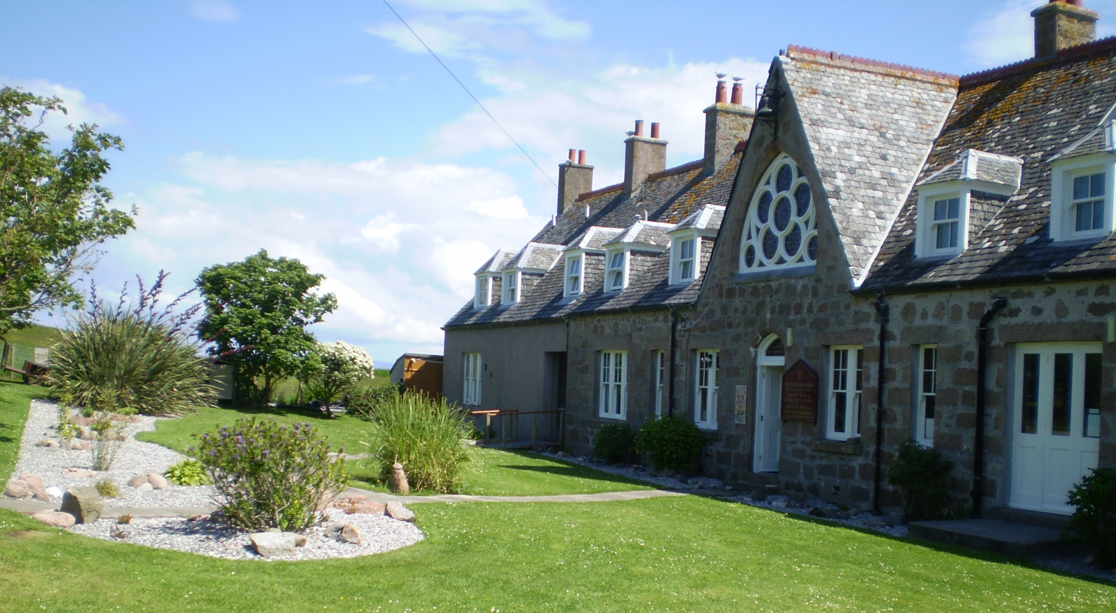
Bishop’s House
IONA
Argyll
PA76 6SJ
01681 700111
bhiona@argyll.anglican.org <bhiona@argyll.anglican.org>;

NEWSLETTER – SPRING 2013

In February, Toben wrote a summary of the winter improvements to Bishop’s House:

‘Our extension had a bit of a rough start, but I am pleased to say it is now well in hand. The first builder lasted less than 24 hours on site, but fortunately Jean, the Board, and our architect were able to contract a new company to come in and complete the project. The build began (again!) at the beginning of the year, which feels rather appropriate; Bishop’s House is now growing alongside the maturing year. As with all builds on Iona, an archaeologist was required to oversee the digging of the foundations. Other than a bit of 14th century pottery, very little was found. As exciting as discovering the final resting place of St. Columba may have been, it would have substantially inhibited our timeline so this is probably for the best. The building team worked very quickly to dig and pour the foundations, and start building up the breeze block to meet the ground level. The walls were built offsite and brought across when they were ready to be erected. Seeing the walls to our lounge come down the village street, in a windstorm, on the front of a forklift is a sight I am not likely to soon forget. They are now in, the floor joists for the first floor are in place, and much of the block work for the fire escape is now in place. Next week they should be starting on the roof trusses, and we hope to be wind and watertight within the next two to three weeks. The team has worked very hard to get the build this far along, and have done very well considering some of the foul weather they have had to contend with. They’re staying in the house with us during the week and are all thrilled with their accommodation. Apparently they are often given sheds and barns to sleep in, so are rejoicing in real rooms with heat and showers. I’m taking photos along the way to document the progress and share it with all those who are curious. They get posted on our Facebook page, which can be accessed with the following link: https://www.facebook.com/media/set/?set=a.380891258657646.92611.335323563214416&type=1&l=77e744753e You should be able to access the photos without a Facebook account, so please do check in and follow the progress along.’

Sadly, because of the many ‘snags’ with the new build, work week this year had to be cancelled.

The email list for Bishop’s House is still active, offering last minute deals for groups and individuals at discounted rates. Contact Toben direct by e-mail at bhiona@argyll.anglican.org if you would like your name to be added to the list.

I enclose an Agenda for the AGM, if you are unable to attend on 20 June, let me have comments or anything adding to the Wish List or anything you wish to have raised under AOB, by 3 June. For those attending the AGM, remember to bring your copy of the Minutes, sent in the Autumn 2012 Newsletter.

Some subscriptions for 2012 are now over-due; those for 2013 will be gratefully received! An individual subscription is £15.00 and for a couple £25.00. Cheques, payable to “Friends of Bishop’s House, Iona” should be sent to Revd. Clephane Hume, Honorary Treasurer, 30 Findhorn Place, EDINBURGH, EH9 2JP (Tel: 0131 667 2996, cah@clephane.plus.com ). Setting up a standing order makes all this much easier – if you have not already done this please contact Clephane, and if you cancel a Standing Order, please let her know.

We are sorry to report the death, last August, of Hilary Wilson, joint Warden of Bishop’s House in the 1990s. She died peacefully after a short illness. Some of the Friends attended her funeral at St John’s church in Edinburgh, where her husband Jeremy continues to sing in the choir. Much missed, but well remembered.

Liz Crichton is working hard to set up our website, she writes:
Work has started on the development of a website for Friends of Bishop’s House. The page will give information about the Friends organisation and BH and will help us to encourage those who have an interest in BH and its future to support us by joining us, making a donation, getting involved at work week, praying for us and the house, and visiting the house and chapel. It will also mean that Friends and others will easily be able to keep up to date with news and events as the website is updated. If you have any photos of Friends Week or Work Week that you are happy to have included in the site could you please send them to Liz Crichton at liz.crichton@virgin.net. If they are prints and you do not have a scanner, please post them to Annandale, Main St, Kirkmichael, PH10 7NT with a note of your address and they can be scanned and returned to you. Thank you

Volunteers needed
An ideal opportunity for those wanting to give something back to Bishop’s House and spend a longer stretch of time on Iona. We are now filling our volunteer schedule for the 2013 season. General Assistants are required to help in housekeeping, in the kitchen, and sometimes even in the garden. In exchange you will be provided with a private room, all meals, two days off per week, pocket money, and our deepest gratitude. No experience necessary, but enthusiasm and willingness a must. Couples or singles are welcome. Please apply to Toben Lewis (iona@island-retreats.org or 01681700111).

Friends will again hold a major fund-raising event for Bishop’s House on the Island, a Coffee Morning and Sale, on Thursday, 20 June. If you would like to make a donation, or have gifts of jewellery, bric-a-brac, books or handicrafts, please either bring them to Friends’ Week or send them to me (Pat) at Bishop’s House but not before Saturday, 15 June.

Autumn Special
Fancy spending some time on Iona this autumn? We’d love to share the beauty of the island and our warm welcome with you, and are offering group bookings in October of this year at a discounted rate. Contact Toben at iona@island-retreats.org or 01681 700111 for further details.
Friends’ Week
Toben says there are some vacancies for Friends’ Week, 15th – 22nd June, so please contact him, as above for further booking details.
If you have not yet experienced Friends’ Week, then why don’t you try this year?
Great fun, and guaranteed to be memorable!

Again, if you receive this newsletter by post and now have an e-mail address, please let me have the details, or indeed if there are changes to your postal address.
The Revd Pat Baggaley, Anglesea, Rosebery Road, West Runton,
CROMER NR27 9QW. 01263 837490 baggaley157@btinternet.com

