FRIENDS OF BISHOP’S HOUSE, IONA

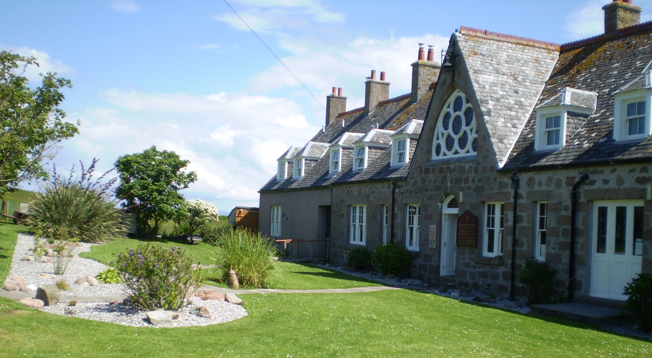
Bishop’s House
IONA
Argyll
PA76 6SJ
01681 700111

NEWSLETTER – SPRING 2011

It a great pleasure for me to begin this letter with good news. First, that our Warden, Benjamin and his wife Justine are expecting a baby in April; what a wonderful way to increase the supporters of Bishop’s House, congratulations to you both! As a consequence, Benjamin and Justine are moving to a home in the village and their self-contained flat will be available for individuals, or couples, adding to the numbers who may stay in the House. It is hoped this will become another valuable asset, especially for people wanting personal retreats or sabbaticals.

It is also good news that the new Bishop for Argyll and the Isles, The Right Reverend Kevin Pearson has been Consecrated and Installed by The Most Reverend David Chillingworth, at the Cathedral in Oban on Friday, 4th February; I was fortunate to be present on the occasion to represent all Friends of Bishop’s House. Despite extremely wet and windy weather, about 250 people from many parts of the Episcopal and sister Churches attended the service. The Cathedral choir sang two anthems with Emma Morwood as the soloist, and the Dean of Windsor, the Right Reverend David Connor preached inspiring words for the new Bishop, and the Diocese. The service sheets included prayer cards, asking for our prayers for Kevin on his consecration, with the words of St Bernard, ‘Life is only for Love. Time is only that we may find God’. Bishop Kevin is planning to be present for some of Friends’ week this summer; and to chair the AGM at 7.45pm on Thursday, 23rd June 2011 at Bishop’s House.

The Revd Liz Toy writes:
‘Joyce Watson’s ordination as a Priest, 11th Sept. 2010 was one of those very special occasions in our lives – not least for Joyce herself. Bishop’s House was filled with guests Joyce had invited, some staying elsewhere on the island. Local friends, clergy from the Diocese of, along with the Rt. Revd. Mark Strange, Bishop of Murray, Ross and Caithness, who ordained Joyce and led the Service, arrived on the morning of the Ordination.
The Service, carefully planned by the Bishop and Joyce, began at the Church of Scotland Parish Church, the sermon preached by The Revd. Canon David Day, a long time friend of Joyce’s. The walk from there to the Abbey, led by a piper and with a cross held aloft, gave a unique ‘extra’ to the day visitors lining the road…! In the Abbey Joyce’s actual ordination took place, then down the (mercifully dry) fields to Bishop’s House, where, as we stood in the packed Chapel, Joyce joined the Bishop in the celebration of the Eucharist - a unique and moving Service. Thank you, Lord, for Joyce, we pray for her special ministry on that island.’

As Benjamin proposed in the last Spring Newsletter, many improvements to facilities in the House have been accomplished over the winter, with much hard work from Benjamin himself, as Justine told me! Bedrooms have been repainted and some reorganised to make them more comfortable, and three bathrooms gutted and upgraded; I’m told also with sound-proofing, as a great bonus for the adjoining bedrooms.

House staff must inevitably change, but Benjamin is planning to phase in a programme of voluntary helpers working in the House. More news later in the year. The email list for Bishop’s House is still active, offering last minute deals for groups and individuals at discounted rates, and there may be two extra weeks this year as Open. If you would like your name to be added to the list, please let Ben know by e-mailing him at bhiona@argyll.anglican.org and he will keep in touch with you direct.

I enclose an Agenda for this years’ A G M, a copy of the Accounts and the Treasure’s report (for 2009) from the last AGM, I failed to send it out last year!. If you are unable to attend the AGM on 23 June, please let me have any comments or if there is anything you would like added to the Wish List or anything you wish to have raised under AOB, by 5 June.

For those who will be at Friends’ Week, please remember to bring your copy of the Minutes, which were sent with the Autumn 2010 Newsletter.

Subscriptions for 2011 are now due to be paid by those who do not have Standing Orders – an individual subscription is £15.00 and for a couple £25.00. Cheques, payable to “Friends of Bishop’s House, Iona” should be sent to Mrs Sarah Hynd, Honorary Treasurer, 1 Newmains Farm Steading, Drem by North Berwick, East Lothian EH39 5BL (Tel: 01620 880 383). May I officially now thank Sarah, on behalf of all Friends, for the hard work she has put in over the years as Honorary Treasurer; but also remind everyone, Sarah stated at the last AGM she wished to retire from the post this year. She would carry on for another year, but that a new treasurer must come forward this year. Please search your hearts, and if anyone feels they may have the skills for this role, do get in touch with Sarah or myself before the AGM in June. Sarah has received a generous donation of £720 in memory of Carole Ritchie Firth, by her sister Mrs Valerie Youll, who wishes the money to be part of the Bursary Fund.
This year as Honorary Secretary has not been straightforward, I will blame my computer! The task I haven’t tackled is to put a Friends page on the Islands Retreat web site, if someone else feels they might be able take this task on, please get in touch with me. It’s a matter of collating and supplying the information to the right person, you would not be expected to actually design or set up the site.

As usual, Friends will be holding their major fund-raising event on the Island, the annual Coffee Morning and Sale, on Thursday, 23 June, to raise funds for Bishop’s House. If you would like to make a donation, or have any gifts, e.g. jewellery, bric-a-brac, books or handicrafts, please either bring them with you to Friends’ Week or send them to Dorothy Jamal or myself at Bishop’s House but not before Saturday, 18 June.

This year celebrates 20 years of Friends, and happy memories of Bishops’ House, including ‘an unforgettable breakfast of kippers after a morning Eucharist’ a first introduction! Fiona Martin realised ‘it was cheaper to travel to France than for people to visit from the south coast’. Names from the guest book contacted by Audrey Clare and Fiona – the Friends were born providing two bursaries quite quickly. Fiona recalls the ‘old rickety blue Morris van’ bought to carry luggage from the jetty, and taking a wheelbarrow and equipment for a BBQ on a remote place on the island! Over the years Friends have given much to the House, and practical help at the beginning of the season in cleaning and painting.

To continue cutting down on postage and stationery costs, if you receive this communication by snail-mail and have an e-mail address, please let me have it as well as changes to your postal address
The Revd Pat Baggaley, Anglesea, Rosebery Road,
West Runton, CROMER NR27 9QW (01263) 837490 baggaley157@btinternet.com

